# Adding Remote Users to Your Azure Database

Now that people are working remotely you are very likely to see the following error when connecting to Azure from Visual Studio…

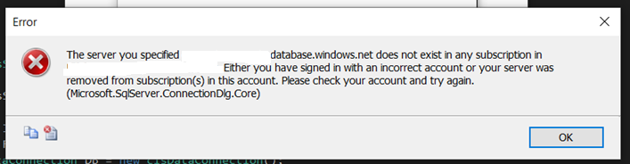

The problem is that the Azure firewall needs the rules updating to allow access from your home ISP.

## Instructions for those Needing Access

The first step is for the people wanting access to make a note of their IP address range.

If you are trying to access the Azure database remotely add the new SQL server in Visual Studio…

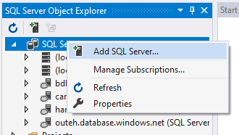

It will then ask for the credentials to the server…

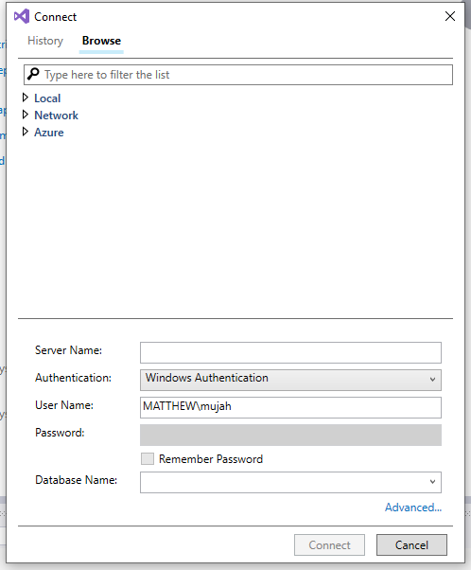

Complete these as usual…

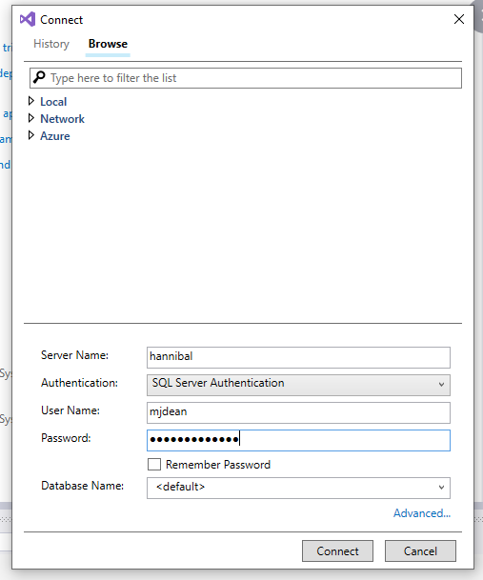

At this stage it should try to add the IP address of your client machine…

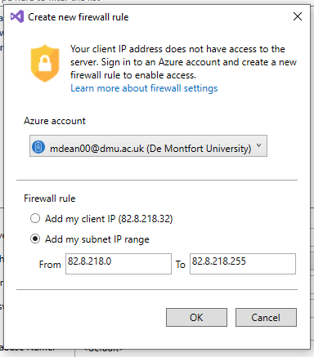

Make a note of the two IP addresses or take a screen shot and send it to the owner of the database.

The next step is for the database owner to update the firewall rules on Azure.

## Instructions for database owners

Login to the Azure portal with your Uni login you should see a screen like this…

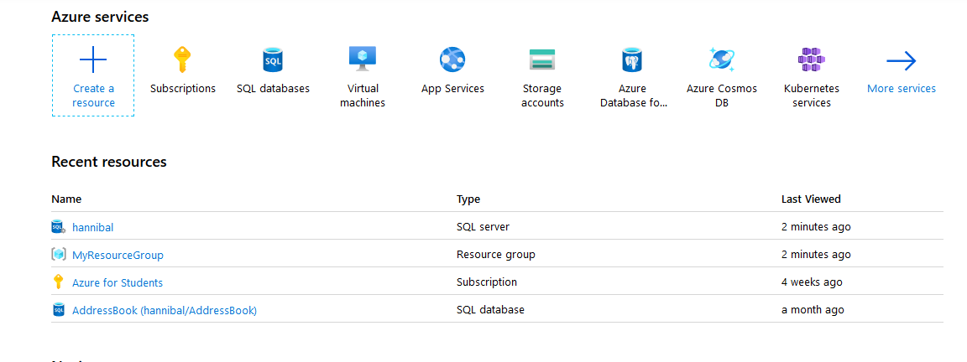

You need to click on the name of your server (in my case hannibal) this will take you to the next screen…

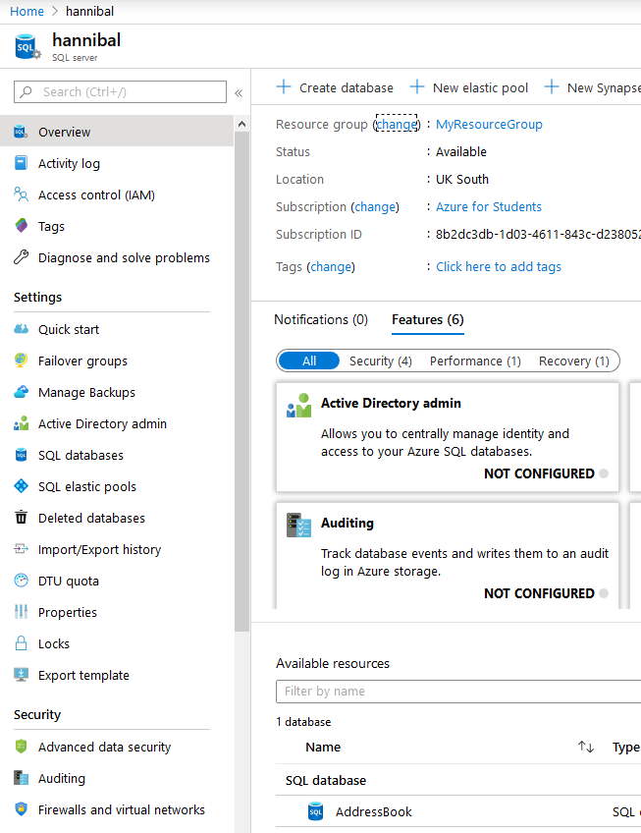

Click on Firewalls and virtual networks in the bottom left

This will take you here…

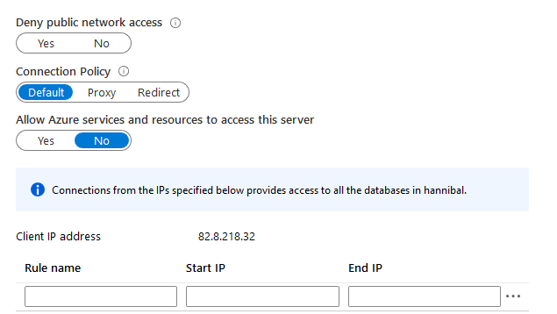

Now that you have the IP address range of the person you are wanting to add…



You may add a new rule in the empty boxes...

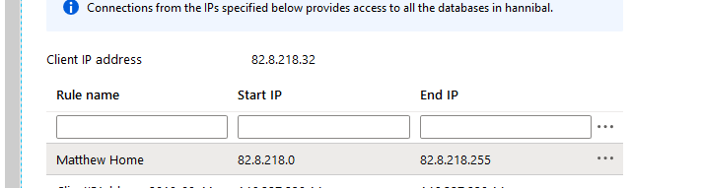

Press return and it will add the new firewall rule below.

Once this is done for each member, they will have access to the server. They will need to repeat the instructions above to connect but this time there should be no error.

Don’t forget to press the save button when done!